Predicting Locoregional Recurrence in Head and Neck Cancer Using Spatial Radiomic Graphs and Graph Attention Networks

Based on: Bae et al., Radiology: Imaging Cancer, 2025

Institution | Christian Medical College (CMC), Vellore, India
Department | Radiation Oncology
Laboratory | QIRAIL (Quantitative Imaging Research and Artificial Intelligence Laboratory)
Dataset | 120 HNSCC patients — pretreatment CT, RT structures, clinical variables, 2-year follow-up
Prediction task | Binary: locoregional recurrence within 2 years (yes/no)
Model | 5-layer Graph Attention Network (GAT) with GTV node readout

1. Introduction
Head and neck squamous cell carcinoma (HNSCC) is one of the most common cancers worldwide, with approximately 900,000 new cases diagnosed every year. The majority of patients present with locally advanced disease and receive definitive radiation therapy, often combined with concurrent chemotherapy. Despite these treatments, locoregional recurrence — the return of the cancer in the same anatomical region after completing treatment — remains the dominant mode of treatment failure and accounts for the majority of disease-related mortality in this patient group.
A critical challenge in managing HNSCC is that outcomes vary widely between patients even when they have similar tumour stage, subsite, and treatment protocol. Some patients achieve durable long-term disease control; others experience recurrence within months of completing treatment. This variability strongly suggests that biological differences between tumours — differences potentially visible on pretreatment imaging — are driving outcome heterogeneity. If these differences could be identified before treatment begins, radiation oncologists could adapt therapy accordingly: escalating radiation dose to high-risk subvolumes, intensifying chemotherapy, or selecting patients for clinical trials of novel agents.
The most widely used computational approach for extracting prognostic information from CT images is radiomics — the extraction of quantitative mathematical descriptors from the tumour volume. Conventional radiomics treats the entire gross tumour volume (GTV) as a single entity and characterises it with one aggregate feature vector covering intensity distribution, texture, and geometry. While associations between radiomic features and clinical outcomes have been reported in numerous studies, this approach has a fundamental limitation: it collapses all spatial information. A region at the invasive tumour margin with an aggressive texture signature is indistinguishable from a region at the tumour core. More critically, the tissue immediately surrounding the tumour — the peritumoral microenvironment — is entirely ignored. Yet this region may harbour microscopic tumour extension, immune infiltration, and early lymphatic spread patterns that are biologically important determinants of whether the tumour will recur after treatment.
This work addresses these limitations by implementing the RadGraph framework proposed by Bae et al. (Radiology: Imaging Cancer, 2025), which represents each patient as a spatial graph and uses a Graph Attention Network (GAT) to learn predictive patterns from both the tumour and its spatial microenvironment. In this framework, the GTV is represented as a central hub node in the graph, and the peritumoral tissue surrounding the tumour is divided into approximately 20 locally homogeneous sub-volumes (supervoxels), each represented as a spoke node connected to the GTV. Each node carries a vector of radiomic features. The GAT then learns, through an attention mechanism, which peritumoral regions are most relevant to recurrence prediction for each individual patient, and how information from those regions should be aggregated to produce a patient-level prediction.
The central advantage of this approach over conventional radiomics is that it explicitly encodes spatial relationships between the tumour and its microenvironment and allows the model to learn which parts of the peritumoral tissue are predictive of recurrence — information that is completely discarded by whole-tumour radiomics. The attention weights produced by the GAT also provide a form of interpretability: they can be mapped back onto the CT scan to generate spatial attention maps showing which peritumoral regions drove each patient's prediction.
This study was conducted at the QIRAIL Laboratory, Department of Radiation Oncology, Christian Medical College (CMC), Vellore, India, on a dataset of 120 HNSCC patients with pretreatment CT scans, GTV delineations, clinical variables, and two-year follow-up outcomes. Of these, 34 patients (approximately 28%) experienced locoregional recurrence within two years. The specific objectives are: (1) to implement a conventional radiomics Random Forest baseline following the Appendix S1 protocol of the original paper; (2) to implement the full RadGraph pipeline covering CT preprocessing, zero-parameter SLIC supervoxel generation, per-supervoxel radiomic feature extraction, spatial graph construction, and GAT training; (3) to train and evaluate the GAT model on the CMC Vellore cohort and compare its performance against the baseline; and (4) to extract and visualise spatial attention maps for clinical interpretation.

2. Methods
The methodology consists of five sequential stages, each of whose output feeds directly into the next. Figure 1 provides an overview of the complete pipeline.
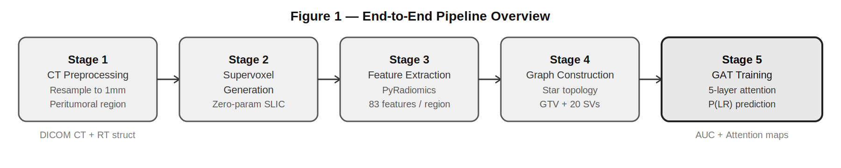
Figure 1 — End-to-end pipeline: five sequential stages from raw DICOM CT to recurrence prediction.

2.1 Patient Cohort and Data Preparation
The dataset consists of patients with histologically confirmed HNSCC who received definitive radiation therapy at CMC Vellore. Patients were included if they had a pretreatment CT scan in DICOM format, a corresponding RT structure file containing a radiation oncologist-delineated GTV, complete clinical variable data, and either a minimum follow-up of 24 months with no documented recurrence or a documented locoregional recurrence occurring at any time point before the analysis date. The 24-month minimum criterion was applied only to patients without recurrence: for patients who experienced recurrence, the outcome is known regardless of total follow-up duration, and excluding them based on follow-up time would artificially deflate the number of positive cases. Of 137 patients with available imaging and clinical data, 121 met the inclusion criteria (34 with locoregional recurrence, 87 without; 16 excluded due to insufficient follow-up in the negative group).
Eight clinical variables were collected for each patient and used as supplementary model inputs: age in years, sex, HPV infection status, AJCC 7th edition tumour stage, ECOG performance status, concurrent chemoradiation administration, primary tumour subsite, and tumour volume in cubic millimetres derived from the GTV delineation. These variables were selected to match the clinical baseline model described in the original RadGraph paper.
Table 1: Patient cohort characteristics.
Characteristic | Value
Total patients (included) | 121
Locoregional recurrence (positive class) | 34 (28%)
No recurrence (negative class) | 87 (72%)
Excluded (insufficient follow-up) | 16 of 137 screened
Median age | ~56 years
Sex | Male majority (HNSCC demographic)
Predominant subsite | Oropharynx
HPV positive | Subset (see clinical data CSV)
CT slice thickness (pre-resampling) | 3 mm
CT spacing (post-resampling) | 1 mm isotropic
Minimum follow-up (negative class) | 24 months
Training / Validation / Test split | 70% / 15% / 15% (stratified)

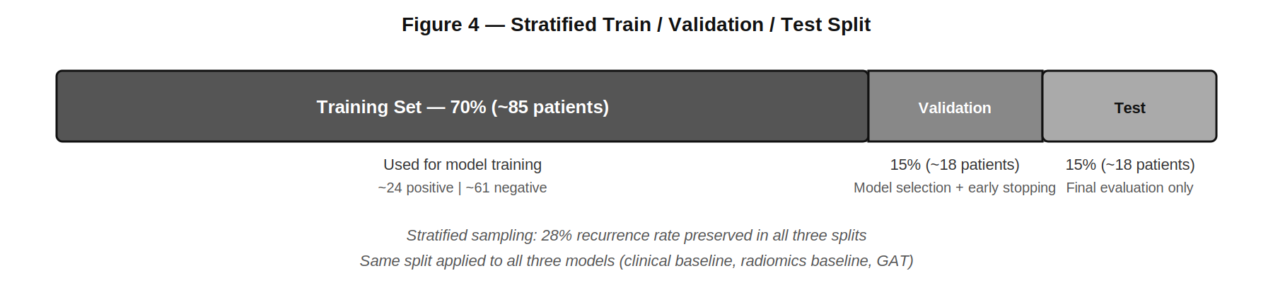
Figure 2: Stratified 70/15/15 train/validation/test split. The 28% recurrence rate is preserved in all three subsets. The same split is used for all three models.
Patients were divided into training, validation, and test sets in a 70/15/15 ratio using stratified random sampling, preserving the 28% recurrence rate in all three splits. The training set was used exclusively for model parameter learning. The validation set was used for model selection, hyperparameter confirmation, and early stopping. The test set was withheld entirely and used only for final performance evaluation. The same split was used for all models to ensure comparability.

2.2 CT Preprocessing
Raw CT scans were acquired at varying slice thicknesses and in-plane resolutions. All CT volumes were resampled to isotropic 1mm voxel spacing using B-spline interpolation as implemented in SimpleITK. The corresponding GTV binary masks were resampled to the same spatial grid using nearest-neighbour interpolation to preserve mask integrity. Resampling to a common isotropic spacing ensures that radiomic features are computed on a consistent spatial scale across patients and removes dependence on scanner acquisition parameters.
For each patient, a region of interest was defined as a 50mm bounding box surrounding the full extent of the GTV in all three spatial dimensions. This peritumoral region constitutes the spatial context from which supervoxels are generated in the subsequent stage. The 50mm margin was chosen to match the definition in the original paper and encompasses the clinical target volume typically irradiated in HNSCC treatment.

2.3 Supervoxel Generation
The peritumoral region was divided into approximately 100 compact, locally homogeneous three-dimensional sub-volumes called supervoxels using the Simple Linear Iterative Clustering (SLIC) algorithm (Achanta et al., IEEE TPAMI, 2012). Each supervoxel becomes one spoke node in the patient graph. Figure 3 shows the full supervoxel generation process: GTV exclusion from the SLIC mask, SLIC segmentation of the annular peritumoral region, and selection of the top-20 supervoxels for graph construction.
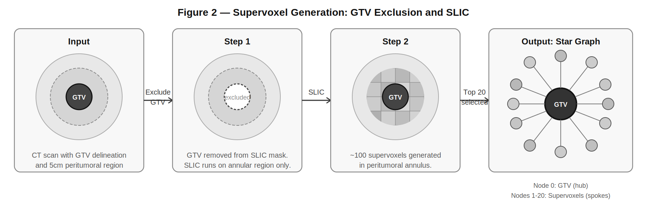
Figure 3: Supervoxel generation. Left: input CT with GTV and 5cm peritumoral region. Centre-left: GTV excluded from SLIC mask. Centre-right: ~100 supervoxels generated in the annular peritumoral region. Right: top-20 supervoxels selected by cosine similarity, forming the star graph with GTV as hub.
Before running SLIC, all voxels belonging to the GTV were removed from the peritumoral mask. This exclusion is critical: the GTV is treated as a separate graph node and should not be fragmented into supervoxels. CT intensities within the mask were normalised to [0, 1] using values computed within the mask only, preventing the large dynamic range of air and bone from compressing peritumoral tissue contrast.
SLIC was run in zero-parameter mode (slic_zero=True) with a target of 100 supervoxels. Zero-parameter mode eliminates manual compactness tuning by adapting the balance between intensity similarity and spatial proximity per cluster: in homogeneous tissue, supervoxels are compact; at tumour margins, supervoxels follow intensity boundaries. Connectivity enforcement was applied to ensure each supervoxel is a single spatially contiguous region.

2.4 Radiomic Feature Extraction
Radiomic features were extracted from the GTV and from each valid supervoxel using PyRadiomics (van Griethuysen et al., Cancer Research, 2017). Six feature classes were computed: first-order statistics (18 features), grey level co-occurrence matrix (GLCM, 24), grey level run length matrix (GLRLM, 16), grey level size zone matrix (GLSZM, 16), grey level dependence matrix (GLDM, 14), and neighbourhood grey tone difference matrix (NGTDM, 5). Shape features were excluded because they describe supervoxel geometry rather than tissue biology. This yields 93 features per region. Supervoxels with fewer than 8 voxels were excluded.
Table 2: Radiomic feature classes extracted per region.
Feature Class | No. Features | What It Captures
First-order statistics | 18 | Intensity histogram: mean, variance, skewness, kurtosis, energy, entropy
GLCM — Grey Level Co-occurrence Matrix | 24 | Spatial relationships between adjacent voxel intensities: contrast, correlation, homogeneity
GLRLM — Grey Level Run Length Matrix | 16 | Runs of consecutive same-intensity voxels: coarseness, uniformity
GLSZM — Grey Level Size Zone Matrix | 16 | Zones of uniform intensity: heterogeneity, zone size distribution
GLDM — Grey Level Dependence Matrix | 14 | Dependency of each voxel on its neighbourhood intensity values
NGTDM — Neighbourhood Grey Tone Difference Matrix | 5 | Difference between a voxel and its neighbourhood average
Shape features | Excluded | Geometry of the region — not informative for irregularly shaped supervoxels
Total (excluding shape) | 93 | Used as input to mRMR and PyRadiomics extraction
For the Random Forest baseline, the top 20 candidate features were selected by Minimum Redundancy Maximum Relevance (mRMR) on the training set. All combinations of 1 to 20 features were evaluated across three sampling strategies on the validation set, and the best-performing combination was used for the final model. For the GAT, the four features specified in Table S3 of the original paper were used directly: GLSZM Grey Level Non-Uniformity, GLCM Inverse Difference, GLCM Inverse Difference Normalised, and GLSZM Zone Entropy. These features collectively capture tissue texture heterogeneity at different spatial scales.

2.5 Graph Construction
For each patient, a star-topology graph was constructed with the GTV as the central hub node (node index 0) and supervoxels as spoke nodes. Only GTV-to-supervoxel edges exist; there are no direct supervoxel-to-supervoxel connections. From the approximately 100 supervoxels generated, the 20 most similar to the GTV were selected using cosine similarity of their four-feature vectors. The hypothesis is that peritumoral regions whose texture resembles the tumour may represent areas of microscopic invasion that are predictive of recurrence. If a patient had fewer than 20 valid supervoxels, all were included.
All node features were z-score normalised using a StandardScaler fitted on the training set only, and clipped at ±5 standard deviations. Each edge was assigned a scalar attribute representing the three-dimensional Euclidean distance between the centroids of the two connected nodes, encoding the spatial context of each supervoxel relative to the tumour. Each patient's graph was stored as a PyTorch Geometric Data object containing the node feature matrix (21×4), edge connectivity (2×40), edge distances (40×1), binary outcome label, and patient identifier.

2.6 Graph Attention Network Architecture
The predictive model is a Graph Attention Network (GAT) as introduced by Velickovic et al. (ICLR, 2018). Figure 4 shows the complete model architecture.
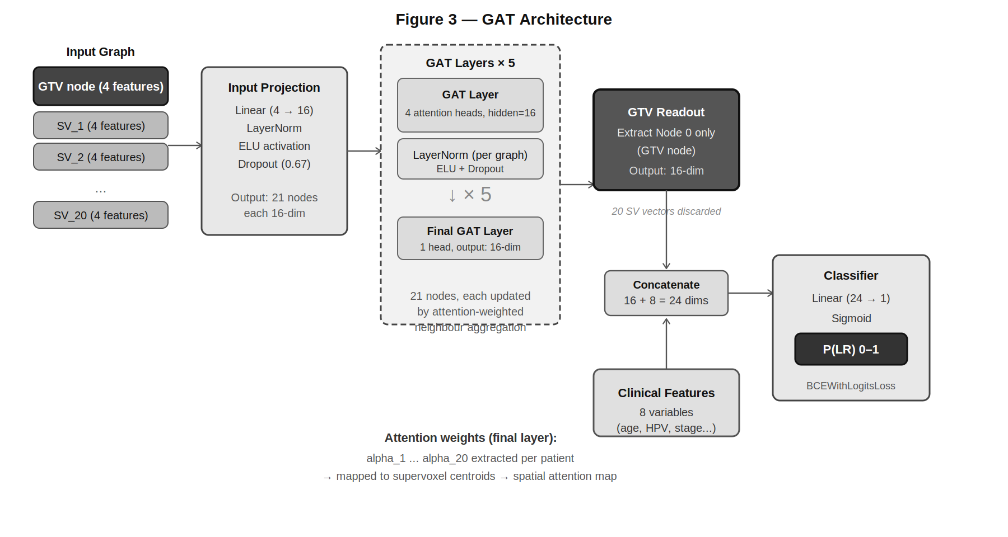
Figure 4 — GAT model architecture. Input: 21-node star graph (GTV + 20 supervoxels), each node with 4 features. Processing: input projection followed by 5 GAT layers with 4 attention heads. Readout: GTV node (index 0) extracted. Fusion: 8 clinical features concatenated. Output: sigmoid probability of locoregional recurrence.
Table 3: GAT hyperparameters for the locoregional recurrence task (Table S2, Bae et al., 2025).
Hyperparameter | Value (LR task) | Rationale
Number of GAT layers | 5 | Depth allows information to propagate across the full graph diameter
Hidden dimension per head | 16 | Small to prevent overfitting on 91-patient dataset
Attention heads | 4 | Multiple independent notions of supervoxel relevance
Dropout probability | 0.67 | Heavy regularisation required for small dataset
Learning rate | 4 × 10⁻⁴ | Table S2 value; optimised on original RADCURE cohort
Weight decay | 7 × 10⁻⁴ | L2 regularisation via Adam optimiser
Batch size | 64 | Table S2 value
LR warmup epochs | 10 | Linear warmup before ReduceLROnPlateau scheduler
Early stopping patience | 15 epochs | Stops training when validation AUC stops improving
Optimiser | Adam | Adaptive learning rate; standard for GAT training
Loss function | BCEWithLogitsLoss | Binary cross-entropy with positive class weighting
Sampling strategy | Intermediate | Partial oversampling + undersampling for 28% positive class
Readout | GTV node only (index 0) | GTV encodes distilled peritumoral context after message passing
Normalisation in GAT | LayerNorm (per graph) | Normalises each patient independently; better than BatchNorm for variable-size graphs
The raw 4-dimensional node feature vectors are first projected to 16 dimensions through a linear layer, LayerNorm, ELU activation, and dropout. The model then applies five sequential GAT layers. At each layer, the GTV computes an attention score for each of its 20 supervoxel neighbours by concatenating the projected feature vectors of both nodes and multiplying by a learnable attention vector, followed by LeakyReLU. These scores are normalised via softmax across all 20 neighbours to produce attention weights summing to 1.0. The GTV's updated vector is the attention-weighted sum of its neighbours' projected vectors. This runs in parallel across 4 attention heads, with results concatenated after intermediate layers and averaged in the final layer. LayerNorm (per graph, with the batch assignment vector), ELU, and dropout are applied after each layer.
The key hyperparameters from Table S2 of the original paper are: 5 GAT layers, hidden dimension 16, 4 attention heads, dropout 0.67, learning rate 4×10⁻⁴, weight decay 7×10⁻⁴, batch size 64, and learning rate warmup over 10 epochs. After the final layer, the GTV node's feature vector (index 0) is extracted as the graph-level representation. After 5 rounds of attention-weighted message passing, this vector encodes a distilled summary of the entire peritumoral neighbourhood. The 16-dimensional GTV readout is concatenated with the 8 clinical variables and passed through a linear classifier, producing a recurrence probability via sigmoid activation.

2.7 Handling Class Imbalance
With 34 positive cases out of 121 patients, the dataset has a 28% recurrence rate. Two complementary strategies were applied. First, an intermediate resampling strategy was used for training: the minority class was oversampled, and the majority class undersampled until both were approximately equal to the geometric mean of the original class sizes. Validation and test sets were kept at their natural distributions. Second, the Binary Cross-Entropy loss was weighted with a positive class weight equal to the negative-to-positive ratio in the training set, penalising misclassification of recurrence patients more heavily.

2.8 Model Training
All models were trained using the Adam optimiser with task-specific learning rate and weight decay from Table S2. A linear learning rate warmup was applied over the first 10 epochs, followed by ReduceLROnPlateau with patience 5 and reduction factor 0.5. Training ran for a maximum of 100 epochs with early stopping: training was halted if validation AUC did not improve for 15 consecutive epochs. The model checkpoint with the highest validation AUC was saved and used for all evaluations. Training was conducted on an NVIDIA Quadro RTX 5000 GPU (16GB VRAM) using PyTorch 2.0.1 and PyTorch Geometric 2.3.1.

2.9 Baseline Models
Two baseline models were implemented. The radiomics baseline used conventional whole-GTV features and a Random Forest classifier following the Appendix S1 protocol: mRMR selection of 20 candidates from the 93-feature set, exhaustive combination search across three sampling strategies, and selection of the highest-validation-AUC configuration. The final Random Forest used 200 trees and a maximum depth of 10. The clinical baseline used only the 8 clinical variables as inputs with the same mRMR and grid search protocol. Both baselines were evaluated on the same held-out test set as the GAT.

2.10 Evaluation
Model performance was assessed on the held-out test set using the area under the receiver operating characteristic curve (AUC) as the primary metric. AUC is threshold-independent and robust to class imbalance. A 95% bootstrap confidence interval was computed from 1000 resamples. Sensitivity, specificity, and accuracy at the Youden-optimal threshold were reported as secondary metrics. All three models were evaluated on the same test split.

2.11 Spatial Attention Map Extraction
After training, spatial attention maps were generated for all test set patients. Attention weights on GTV-to-supervoxel edges were extracted from the final GAT layer, averaged across the 4 attention heads to produce one scalar per supervoxel per patient. These weights were mapped back to their three-dimensional spatial locations using supervoxel centroid coordinates, producing a spatial heatmap overlaid on the CT scan. Regions with high attention weight indicate peritumoral areas that the model found most predictive of recurrence for that individual patient.

2.12 Software
Table 4 — Software packages and versions used in this implementation.
Package | Version | Purpose
Python | 3.8 | Runtime environment
PyTorch | 2.0.1 | Deep learning framework — GAT training and inference
PyTorch Geometric | 2.3.1 | Graph neural network operations and DataLoader
torch-scatter / torch-sparse / torch-cluster | 2.1.2 / 0.6.18 / 1.6.3 | PyG sparse operations (CPU wheels)
SimpleITK | 2.2.1 | DICOM CT loading and isotropic resampling
rt-utils | 1.2.7 | RT structure DICOM parsing and GTV mask extraction
PyRadiomics | 3.0.1 | Radiomic feature extraction from CT sub-regions
scikit-image | 0.21.0 | SLIC zero-parameter supervoxel generation
scikit-learn | 1.3.0 | Random Forest, MinMaxScaler, StandardScaler, AUC metrics
scipy | 1.10.1 | Statistical computations (last version supporting Python 3.8)
mrmr-selection | 0.2.6 | Minimum Redundancy Maximum Relevance feature selection
pandas | 2.0.3 | Clinical data handling and results export
numpy | 1.24.3 | Array operations (installed before PyTorch as a dependency)
joblib | 1.3.2 | Model serialisation and parallel processing
GPU (hardware) | Quadro RTX 5000 | 16GB VRAM — used for GAT training
Random seed | 42 | All stochastic operations — training, sampling, splits

